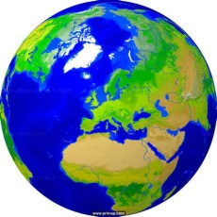

Around the World Maths Challenge
During children’s journey through Windmill Hill Academy, they will travel around the world on a multiplication challenge. They will start their journey during year 1 at the United Kingdom and visit different countries until they complete the final challenge and return once again to the United Kingdom.
Within class, they will have a strict 3 minutes to complete the appropriate assessment – once they have ALL answers correct, their passport in their homework book will be signed and they move to the next country.
(Y1 will begin their journey later in the year)
United Kingdom  France  Spain  Italy  Egypt  Kenya  South Africa  India  Australia  China  Canada  USA  Mexico  Brazil  United Kingdom | 2 and 10  2 and 5  3 and 5  3 and 4  3, 4 and 6  4, 6 and 8  6, 8 and 9  7, 8 and 9  7, 9, 12 and square numbers  Division for 3, 4, 6 and 8  Division for 6, 7, 8 and 9  Division for 7, 9, 12 and square roots  Random multiple facts  Random division facts  Any multiple or division (oral) | Multiplication and division home learning guidance  - Counting in steps of…  Use toys, money, stairs, paving slabs, arrays etc  An array is an arrangement of a set of numbers or objects in rows. It helps you understand calculations by displaying them visually. It can be really useful when multiplying two numbers or dividing one number by another.  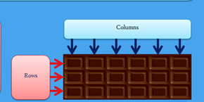  Arrays can be seen in everyday objects like egg boxes and bars of chocolate.  Showing multiplication  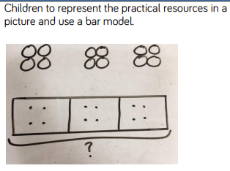  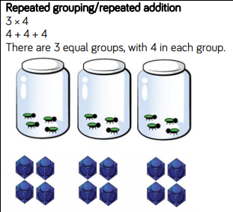  Showing division  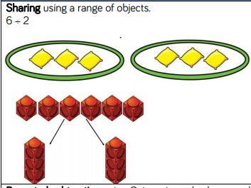  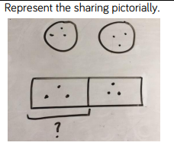  - MyMaths activities  - Listen to and sing fun rhymes and songs  - Board games / ICT games  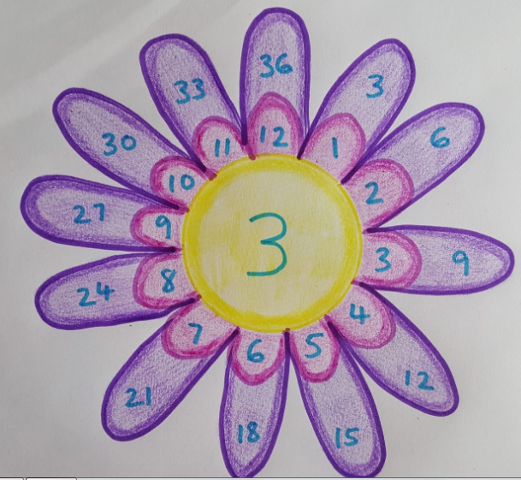  - Draw a Waldorf multiplication flower  - Quizz regularly  Once you think your child is getting the hang of their times tables, it’s time to put them to the test. It’s best to do this is when there’s nothing else really going on, like while you’re walking them to school.  - Reward and praise their efforts  Remember that you shouldn’t just reward your child for getting answers right Don’t be afraid to give them a treat if you can see they’ve been trying hard but haven’t quite mastered their times tables yet.

